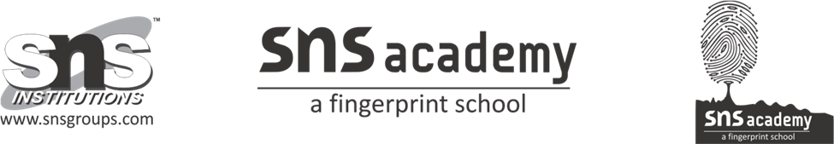
Periodic Test-II
Computer Science(Code083)
Class: XI Date:10.11.22
Time:1hr 45 mins Marks:40

Part-A

Section-I
Choose the best possible option.
1. What is the maximum length of a Python identifier? 1
a.32 b.16 c.128 d.No fixed length is specified.

2. What will be the output of the following code snippet? 1
print(2**3 + (5 + 6)**(1 + 1))

a.129 b.8 c.121 d.none of the above

3. How is a code block indicated in Python? 1
a.Brackets. b.Indentation. c.Key. d.None of the above.

4. What will be the output of the following code snippet? 1
print(type(5 / 2))
print(type(5 // 2))

a.float and int b.int and float c.float and float d.int and int

5. What will be the output of the following code snippet? 1
a = [1, 2, 3, 4, 5]
sum = 0
for ele in a:
sum += ele
print(sum)
a.15 b.0 c.20 d.None of these
6.Which of the following concepts is not a part of Python? 1
a.pointers b.Loops c.Dynamic Typing d.All of the above

7. Which of the following types of loops are not supported in Python? 1
a.for b.while c.do-while d.None of the above

8. What will be the output of the following code snippet? 1
def check(a):
print("Even" if a % 2 == 0 else "Odd")

check(12)
a.even b.odd c.error d.none

9. What will be the output of the following code snippet? 1
example = ["Sunday", "Monday", "Tuesday", "Wednesday"];
print(example[-3:-1])

a.[‘Monday’,’Tuesday’] b. [’Sunday’,‘Monday’]
c.[‘Wednesday’,’Thursday’] d. [’wednesday’,‘ Monday’]

10. What will be the output of the following code snippet? 1
dict1 = {'first' : 'sunday', 'second' : 'monday'}
dict2 = {1: 3, 2: 4}
dict1.update(dict2)
print(dict1)

a.{‘first’:’sunday’,’second’:’monday’,1:3,2:4}
b.{‘first’:’sunday’,’second’:’monday’}
c. {1:3,2:4}
d.None of the above

